Collin Avidano

Problem Set 1

# Part A

1. Give an example of how one can exploit the associative property of convolution to more efficiently filter

an image.

In the case of separable filters. The associative property of convolutions allow us to reduce the operations we have to perform to filter images. One example would be the convolution of a derivative filter with a gaussian filter before applying it to the actual image to be filtered. Given our image is represented by f, our derivative is filter is g and our gaussian filter is g rather than performing g*(h*f) we can perform (g*h)*f . This is important because the filters g and h for a given size do not change between images. As we switch between images we only change the matrix f. In this way we are leveraging the associative properties as rather than doing 2 computations per image h*f then g*(h*f) we can use the precomputed g*h and only do 1 convolution operation per image.

2. This is the input image: [0 0 1 1 0 0 1 1]. What is the result of dilation with a structuring element

[1 1 1]?

A = [0 1 1 1 1 1 1 1]

***3. The filter f’ = [0 -1/2 0 1/2 0] is used as the filter to compute an estimate of the first derivative of

the image in the x direction. What is the corresponding second derivative filter f". (Hint: Asymmetric

filters must be flipped prior to convolution.)

Flip filter and cross corelate with the original f' eg f' convolve f'

[ 0.25 0 -0.5 0 0.25 ]

4. Name two specific ways in which one could reduce the amount of fine, detailed edges that are detected

with the Canny edge detector.

Increase the initial threshold value in the canny detector that occurs before non maximal suppression or hysteresis thresholding.

Since Im not actually sure the above is a step.

You could increase the strength(sigma) of the gaussian filter (or strength of the gaussian used in the derivative of the gaussian filter) as this would have the effect of reducing the sharpness of edges (equivalently their value after the convolution with the derivative filter) which could cause them to be ignored by the later thresholding operations.

Or to prevent thinner edges from being detected by Hysteresis Thresholding you would adjust the lower bound of this step. By increasing it less thin edges would be continued or connected in the image .

5. Describe a possible flaw in the use of additive Gaussian noise to represent image noise.

As in the shortcomings of assuming an image's noise is additive white gaussian,

The biggest issue with this is that you are making the assumption that all noise is white noise. There is also salt and pepper noise / impulse noise which can occur when pictures are taken as a result of various hardware limitations including bit transmission errors and ADC errors. Applying linear filters, such as a gaussian blur, to try to remove such noise is not as effective as applying non linear filters, such as median filters, for salt and pepper noise. Incorrect characterization of your noise will thus leave a high quantity of noise which in any case can lead to many issues.

6. Design a method that takes video data from a camera perched above a conveyor belt at an automotive

equipment manufacturer, and reports any flaws in the assembly of a part. Your response should be

a list of concise, specific steps, and should incorporate several techniques covered in class thus far.

Specify any important assumptions your method makes.

In terms of defects I would assume this is something thats actually a sufficiently large error such as a bent part or large crack.

In order to detect the deformity in the part we can look for large deformities from a regular part. To represent the “perfect part” we first need a distance transform. Note in template matching schemes such as this scale and rotation drastically affect detection therefore the image from which will compute the distance transform will be from the same position as we take the images to compare to. Additionally we will assume the parts come in in the same orientation as the perfect part.

To make the distance transform “template” we will run first to take the image of the perfect part. If we for some reason were using an rgb camera we would convert to grayscale. Then we will run median noise filtering to reduce impulse noise on the image. Then we will run the steps for canny edge detection. This starts with convolving the image with a gaussian filter to remove gaussian noise. Then convolving the images with directional derivative filters which we will say sobel in this case and then we computer the gradient magnitude as an approximation of the directional gradients. That is the value of a pixel in the gradient magnitude image vs the two direction magnitude images is $\sqrt(g_x ^2 + g_y ^2) $ and the angle is arctan(g_y / g_x) . We would store both of these in separate images as we will use the gradient angle in non maximal suppression.

Then we would do non maximal suppression. This works by taking the angle of the gradient magnitude we calculated in the last step and and moving out by one pixel interpolating by the pixels to the sides of it if needed and then determining if the gradient magnitude of that pixel is higher than that of the pixel we moved outward from. If not we zero that pixel and repeat this operation across pixels until we should have 1 pixel edges only.

Then we run hysteresis thresholding to reconnect edges. Essentially we set both a high and low threshold to group pixels into high or low gradient values then we start at all high edge values and if they connect to weak edge values continue those edges setting them to be high values. Then we remove all non connected weak edge values when we are done. This should leave us with the results of the canny edge detector. Now with our perfect template in hand we compare incoming potentially damaged parts. To do this we repeat all of the same steps with an image of these new parts obtaining a canny edge detected image. Then we will generate a distance transform map for this input image. The distance transform map generated by doing a series of 2 forward backwards up and down passes. You start with an image of all infinities. Whenever you encounter a high pixel, which is all that should be left with the canny detection, you set the distance to zero. As you move away you increment by the min of the pixel you are at and the pixel you came from + 1 (basically representing your growing distance from the edge). Then do a pass in the other direction which resolves the other direction (note in the forward pass if the next edge was five pixels from the last edge the value to the left of the first edge would be 4 which it should be one. This is what the backward pass fixes).

To test how close it is to the perfect part we try to find the lowest chamfer distance possible rotating and scaling our template edges over the distance transform map of the input image. In the places where our template has an edge we add the value of that location in the input image distance transform to a total sum. The lowest of all these sums can be found using something like Iterative closest points which I will not describe here. This lowest sum is the chamfer distance we will use for describing the deformity of the part. Now knowing this we would set an arbitrary bound on what constitutes a deformed part vs a correct part. Lower chamfer distance means a more perfect part. The abs value of this chamfer distance however varies with the resolution of our camera and the other factors I mentioned earlier(rotation, scale) so testing and tuning will be needed to distinguish slightly damaged or deformed parts. However this scheme should work for detection of large deformities even with bad parameters.

# Part B

B1

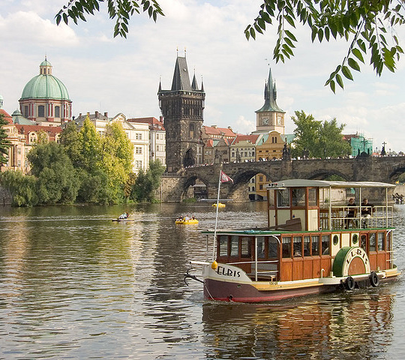

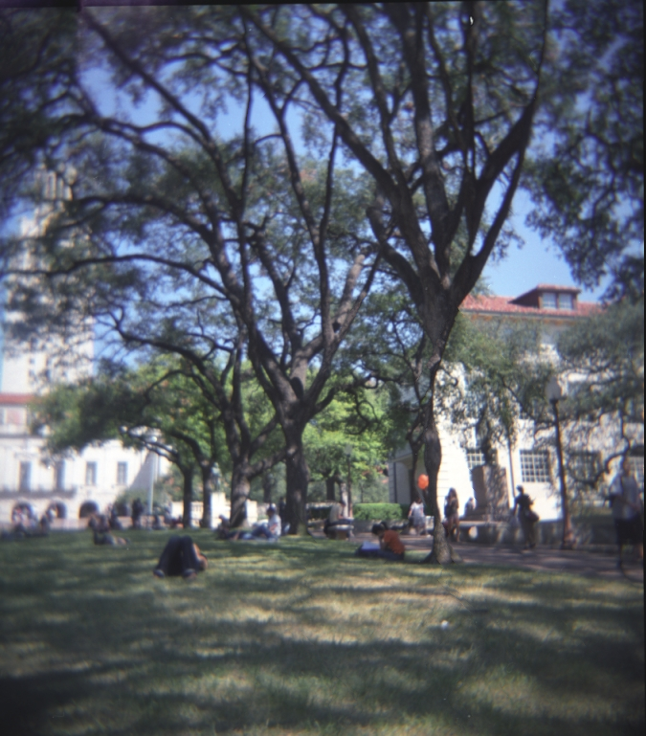

B2

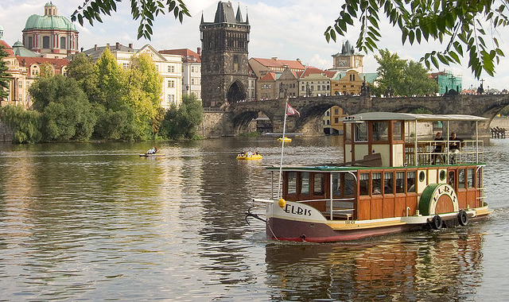

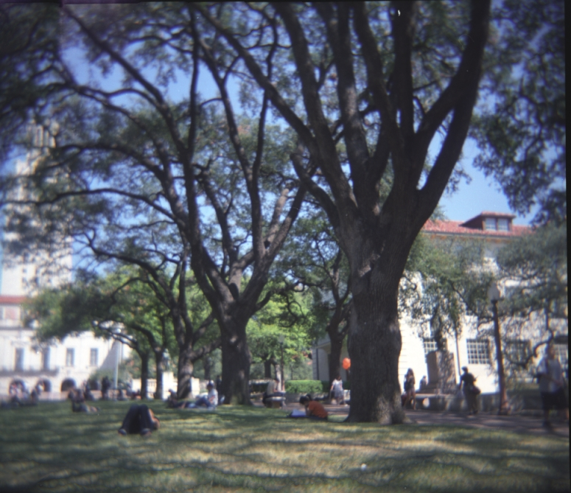

B3

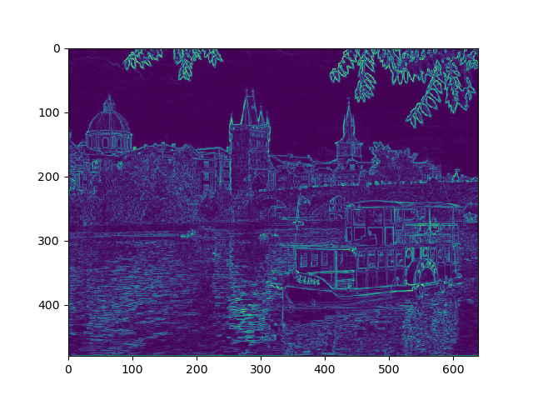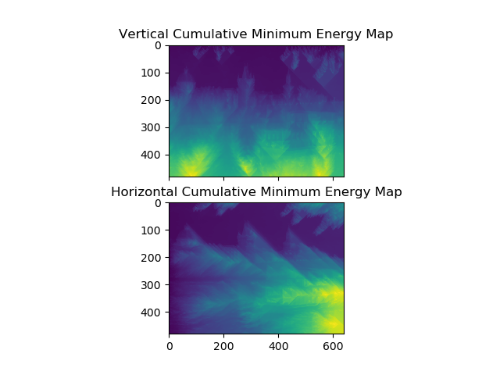(c) Explain why these outputs look the way they

do given the original image’s content.

The energy image represents the relative detail of any edge on its own. Looking at the original energy image the closer to green an edge is the stronger its gradient magnitude and thus the stronger the edge. So the buildings of course have bright green edges where there are sheer faces and the water and trees softer edges.

Looking at the energy map we are trying to judge the detail we encountered and would thus have to remove going across the image. Remember, these were constructed by going across the image left to right in the horizontal case or top to bottom in the vertical case. As the dynamic programming table was built up it was constantly the min of the last column or row added to its own energy. So any path that progressed from left to right in the case of horizontal would continuously build up and have more energy and thus a brighter green. What this means is that at this point on the far right side the paths that pass through the lowest gradients as possible are still strong relative to the rest of the image thus you would remove a lot of detail if you made a seam ending at that region. If we look at the original image the lower right hand corner contains many strong gradients as a result of the boat in the water and even moving leftward the water has many decently strong gradients. Consider our eventual seam as a river and this map as a landscape height map, our river going to take the path of least resistance and thus will stay away as much as it can from the high terrain green areas, such as the water and the boat, which cause the gradients of all things to the right of them to be higher, and flow through the blue that represents the sky. This region, tracing left to right, has many paths to it through the rest of the sky off to the left. In other words is all one large connected region which does not have any strong edges in it, and thus has a very low gradient magnitude. This low gradient magnitude means it represents a region that does not have much detail thus is a strong candidate for removal. And as we will see in the next problem our seam will flow right through this low gradient magnitude blue region.

4

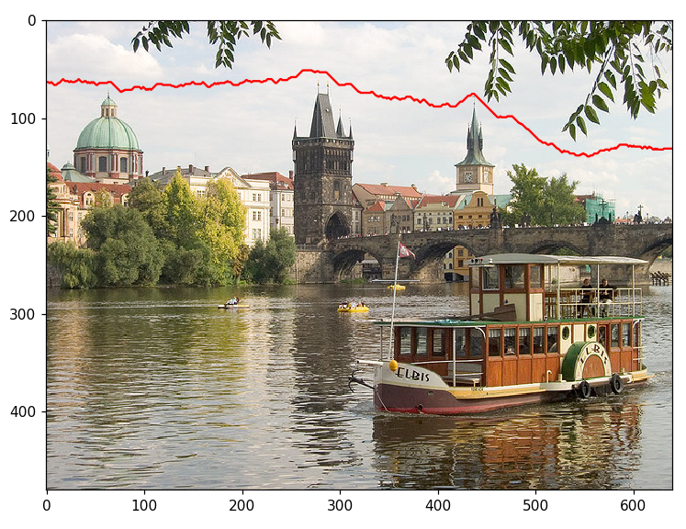

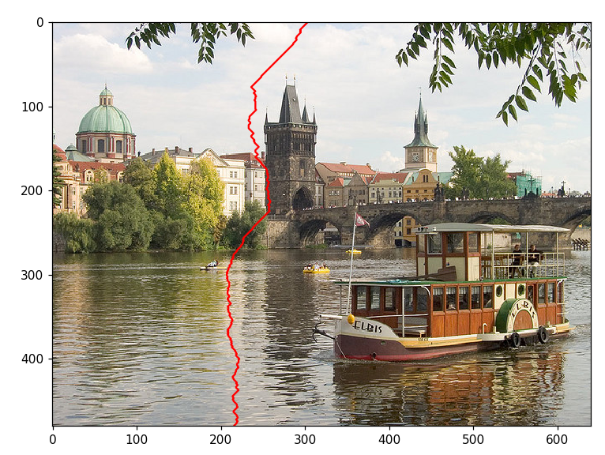

I explained at the end of number 3s answer that the horizontal seam ends up where it is because the sky has a very flat texture all the way across horizontally thus only the energy map it forms a low energy contour going left to right with minimal “resistance” from strong edges. And surely enough our horizontal seam flow left to right dead middle of the darkest blue region where the texture is fairly flat all the way across. However the vertical has a much harder time finding a path top to bottom. We do notice in the map the path it took is still the lowest energy from top to bottom. If we look at both the energy image and at the original image we can reason as to why. Notice the clock tower is heavily shadowed on one side and thus has a very flat texture compared to the rest of the image because of this darkness. This reduces the energy in this region. Additionally the region where the seam passes through is in between the reflections of the clock tower and the trees on the water. These features additional detail and thus energy to these regions so the seem prefers to flow through where nothing is being reflected.

B5

I decided to try using the Roberts filter where R_x = [[1,0],[0,-1]] R_y =[[0,1],[-1,0]] instead of the Prewitt filter. This filter is designed to better detect edges at a 45 degree angle vs just left and right / up and down as with the Prewitt filters and this is kinda intuitive looking at the filters themselves(only transition -1 to 1 on the diagonals)

Roberts Filter

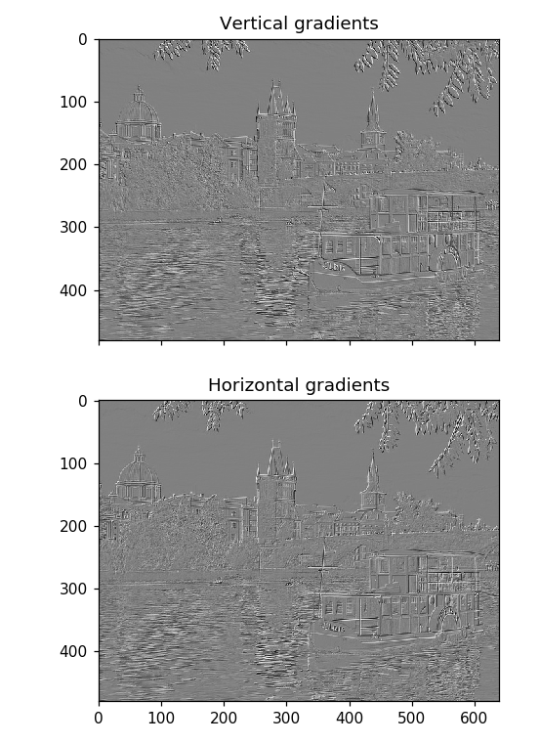

Prewitt Filter

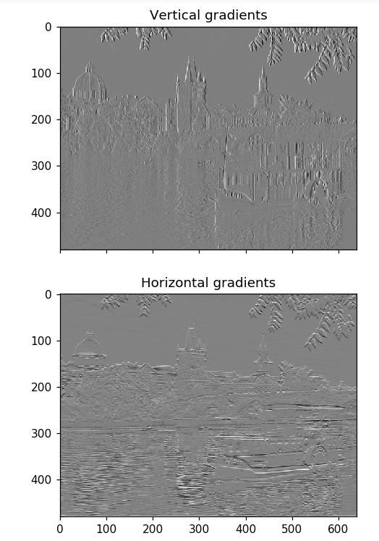

Here we very clearly see that the Prewitt Filter really only catches gradients in the direction its going. Looking at the vertical gradient of the clock tower on the right we see that the faces of it looks as though its almost melting or as though the overhangs have been dragged over the face of them. This is because the detailed edges such as the rotary clock don't flow parallel to the vertical or horizontal of the image. However these angled edges of the clock face are quite a bit clearer with the Roberts filter.

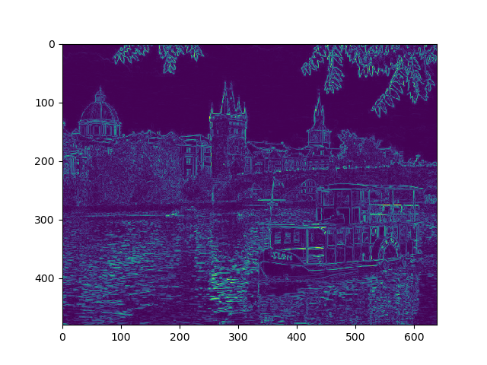

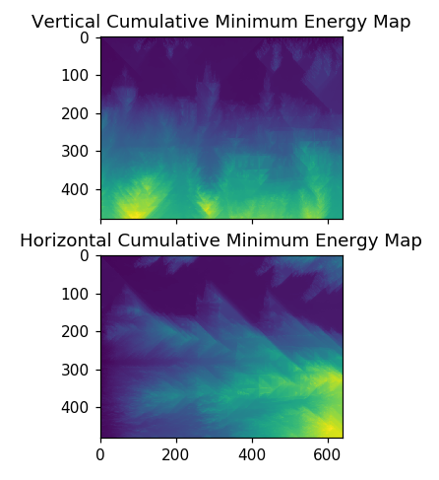

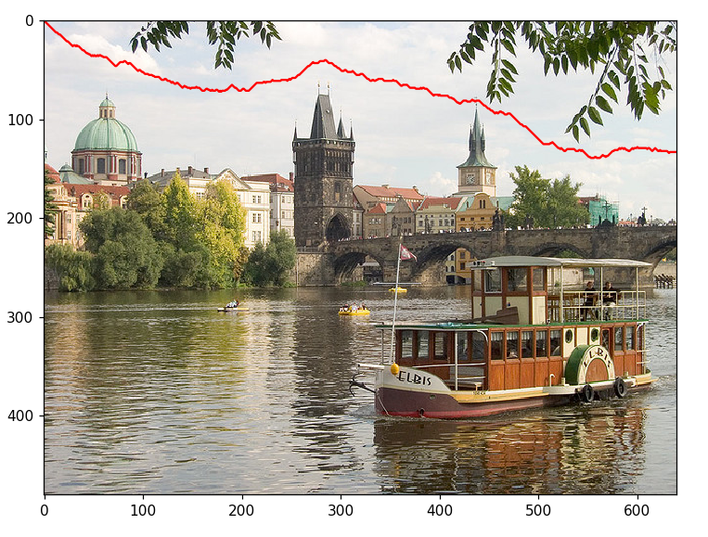

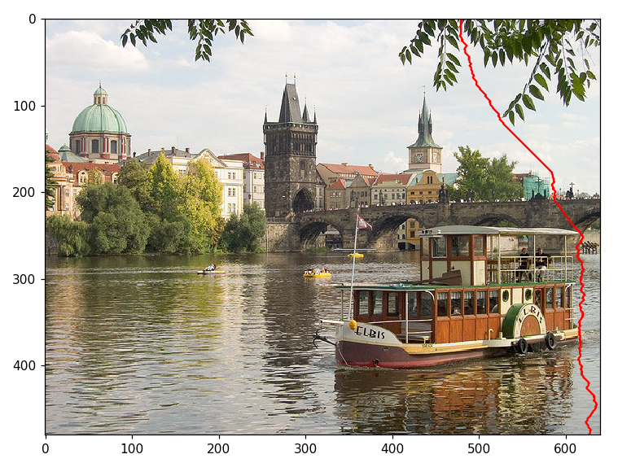

If we look at the energy image when using the Roberts filter and the resulting seams we get some interesting results most notably that the water with reflections off to the left of the boat has much stronger reflections. This is because the waters waves are closer to a 45 degree angle and thus are stronger with the Roberts filter. This causes the vertical seam to avoid this area and instead go through the clouds off to the right which are aligned with the x axis. In the horizontal seam the clouds at 15y are much more strongly picked up because that cloud edge is angled going off to the top right of the image. So the seam adjusts slightly and take a path across the texture wise flat diagonal of the cloud above it.

6b

For this question I chose three images: A picture of me at the grand canyon, a picture of my dog and a picture of myself in the mirror.

Input 600x400

Output 600x300

Original

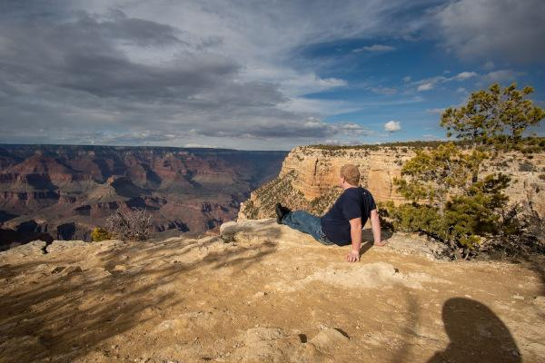

Simple 100 pixel height reduction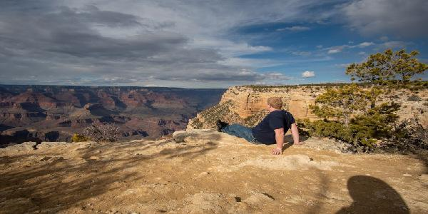

Seam Carving 100 pixel height reduction

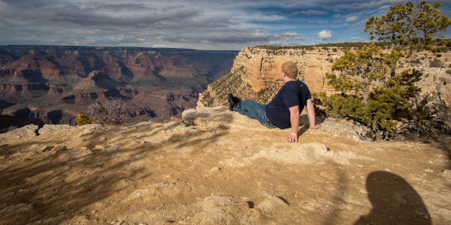

Note the horizontal seam carving on this image is very pleasing. Unlike the simple resizing which removes row from my body in the picture as well as other details, seam carving cuts out mostly the sky, which has much less detail than the canyon below. However this only worked out so nice because the horizontal gradient had a region such as the sky where there wasn't important detail. To illustrate this point is my dog Mac.

Input 400x533

Output Height Reduced 400x433

Output Width Reduced 300x533

Original

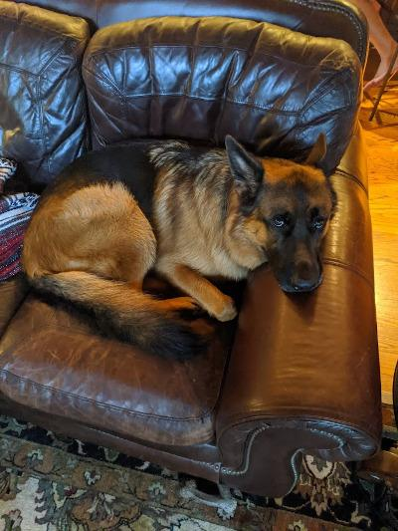

Seam Carving 100 pixel height reduction

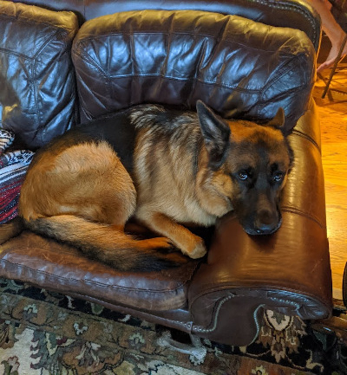

When we take a horizontal filter to the image we see that low energy areas such as the flat leather of the cushion he is on is cut out however when we go vertically it's another story. Notice that the space in between a cute german shepherds eyes such as Macs forms a clean low energy contour which in this case also continues to be low energy because of the leather sidearm he is laying on.

Simple 100 pixel width reduction

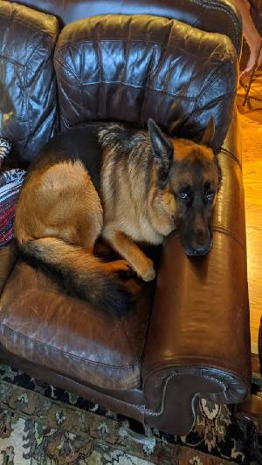

Seam Carving 100 pixel width reduction

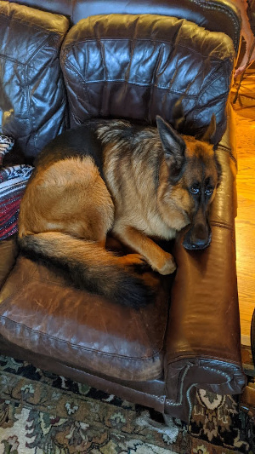

This time the seams went straight between his eyes squishing the cute dog and making him look like an alien. And this is one of the major downfalls of seam carving. It only preserves details represented by regions of dense edges, not those details which arise in between such regions and are influenced by having those low density spaces around. In other words it's not “context aware”. Situations where the placement of features on a particular object are mushed together by seam carving, especially if they are separated by low detail regions which is prevalent in pictures of peoples faces.

There are also other issues with keeping detail especially if its not really important to the context of the image consider the following picture of my face.

Input 184x245

Output 134x245

Original

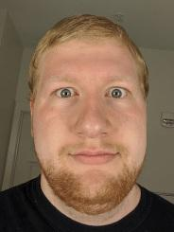

Simple 50 pixel width reduction

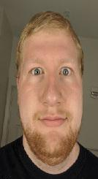

Seam Carving 50 pixel width reduction

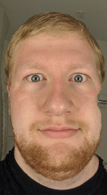

Notice the high density edges of the towel bar in the background are not removed by the seam carving algorithm over the side of my face which, yes, is fairly smooth. However the towel rack is clearly not a part of the foreground and thus, in an artistic sense, should be the first thing to be removed. Segmenting the image can help with this.